Inverse Wave Equation Generative Modeling
Introduction:
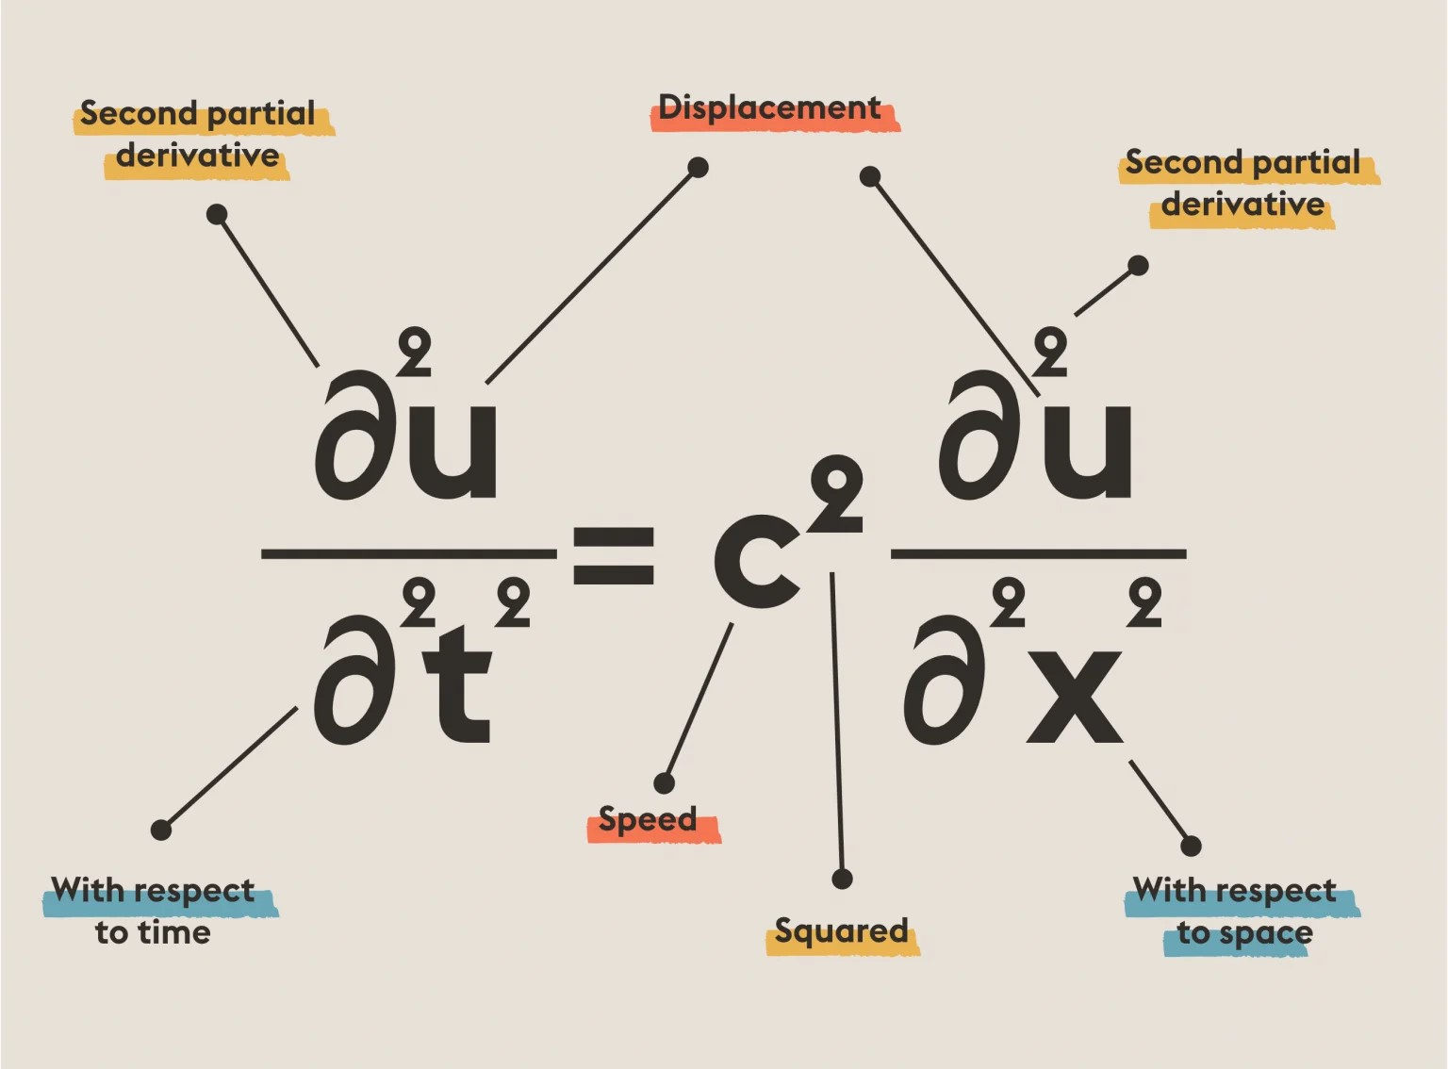
The wave equation is one of the fundamental ideas of physics. The tangible implications of it run deep in our world. From analyzing the behavior of quantum particles to understanding tidal risings to developing 5G communication signals, all the fields of engineering and physics are entailed with stories of vectors and fluctuations that can only be modeled using the wave equation.

Physics and Machine Learning have seen a partnership evolve between them. Numerous research in diffusion-based models have shown incredible success in image synthesis capabilities surpassing GAN based models. Notably, Song et al. (2020) showed that the generative process is equivalent to reversing a fixed forward diffusion where the modeling framework is integrated into a continuous Stochastic Differential Equation. This has been applied to various tasks such as text-to-image generation, 3D generation, text-to-video generation, etc.
A more recent work is the Poisson Flow Generative Model(PFGM) inspired from the field of electrostatics. The data distribution is treated as charge distribution and this charge produces a field line that extends radially outward where the complex source field line distribution simplifies into a uniform distribution. Hence source data can be faithfully reconstructed from a random sample from the uniform distribution by following the said field lines in reverse. The results of this model are better FID and Inception scores compared to diffusion models.
Another model is an inverse heat dissipation model (IHDM), which aims to reverse the heat equation. The idea has proved to have smooth interpolation, latent disentanglement, and data efficiency.

Research Methodology:
In this paper, I propose an image generative model by reversing the wave equation. I am investigating this because the previous works stated above show a very clear trend that physics based equations have a promising generative modeling counterpart.
First, a general solution to the wave equation is of the following form:
where exp is the exponential function, A is any complex number, and ω, kx, and ky are three numbers such that ω = f(kx,ky). The number ω is called the angular frequency of the wave, and the vector k = (kx,ky)​ its wave vector. This relation between the angular frequency and wave vector is called the dispersion relation. It can be used to infer some important properties of the waves like the speed at which the information and energy it carries propagate.
Additionally, if we add -iγ|k| to the angular frequency, it functions as a dissipative component, which works by removing energy from the wave thereby decaying it.

The idea is to use this equation to propagate any image forward in time which will lead it to a prior distribution. Then the neural network can reverse the flow, essentially exhibiting a generative process by reversing any randomly drawn image from the said prior.

Results & Sample Code:
Forward process of a sample image. Reverse process


Forward process
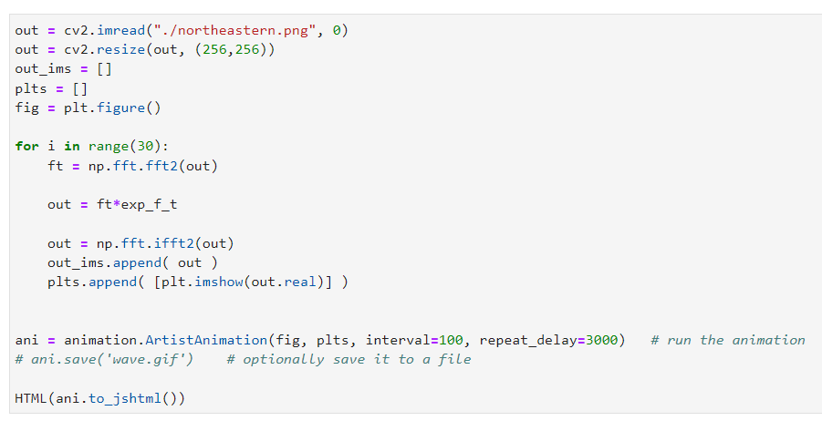
Reverse Process
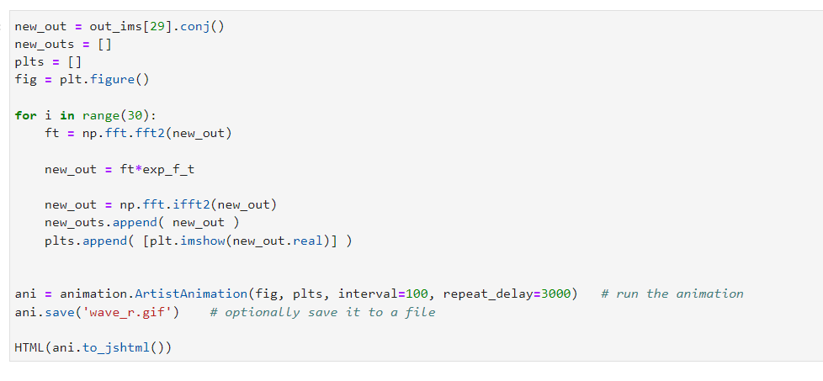

Challenges:
As is evident from the simulation attached above, the images propagate towards a non-trivial prior distribution.
One reason is that I have not used any dissipative components in the wave propagation. If used, it will remove high frequency components and would result in a better prior as the image evolves. That remains to be tested.

References:
1. Inverse Heat Equation (https://arxiv.org/pdf/2206.13397.pdf)
2. Simulating wave propagation with the optical Fourier engine (https://medium.com/optalysys/simulating-wave-propagation-with-the-optical-fourier-engine-f4a9f2e74d28)
3. GENPHYS: From Physical Processes to Generative Models (https://arxiv.org/pdf/2304.02637.pdf)

